,,Joins in SQL server are used to query (retrieve) data from 2 or more related tables. In general tables are related to each other using foreign key constraints.
n SQL server, there are different types of JOINS.
1. CROSS JOIN
2. INNER JOIN
3. OUTER JOIN
Outer Joins are again divided into 3 types
1. Left Join or Left Outer Join
2. Right Join or Right Outer Join`
3. Full Join or Full Outer Join
Now let's understand all the JOIN types, with examples and the differences between them.
Employee Table (tblEmployee)
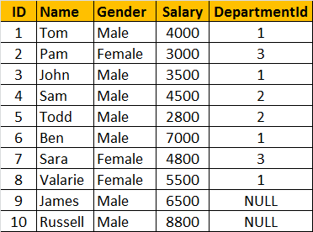
Departments Table (tblDepartment)
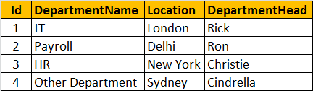
SQL Script to create tblEmployee and tblDepartment tables
Create table tblDepartment
(
ID int primary key,
DepartmentName nvarchar(50),
Location nvarchar(50),
DepartmentHead nvarchar(50)
)
Go

Insert into tblDepartment values (1, 'IT', 'London', 'Rick')
Insert into tblDepartment values (2, 'Payroll', 'Delhi', 'Ron')
Insert into tblDepartment values (3, 'HR', 'New York', 'Christie')
Insert into tblDepartment values (4, 'Other Department', 'Sydney', 'Cindrella')
Go

Create table tblEmployee
(
ID int primary key,
Name nvarchar(50),
Gender nvarchar(50),
Salary int,
DepartmentId int foreign key references tblDepartment(Id)
)
Go

Insert into tblEmployee values (1, 'Tom', 'Male', 4000, 1)
Insert into tblEmployee values (2, 'Pam', 'Female', 3000, 3)
Insert into tblEmployee values (3, 'John', 'Male', 3500, 1)
Insert into tblEmployee values (4, 'Sam', 'Male', 4500, 2)
Insert into tblEmployee values (5, 'Todd', 'Male', 2800, 2)
Insert into tblEmployee values (6, 'Ben', 'Male', 7000, 1)
Insert into tblEmployee values (7, 'Sara', 'Female', 4800, 3)
Insert into tblEmployee values (8, 'Valarie', 'Female', 5500, 1)
Insert into tblEmployee values (9, 'James', 'Male', 6500, NULL)
Insert into tblEmployee values (10, 'Russell', 'Male', 8800, NULL)
Go
General Formula for Joins
SELECT ColumnList
FROM LeftTableName
JOIN_TYPE RightTableName
ON JoinCondition
CROSS JOIN
CROSS JOIN, produces the cartesian product of the 2 tables involved in the join. For example, in the Employees table we have 10 rows and in the Departments table we have 4 rows. So, a cross join between these 2 tables produces 40 rows. Cross Join shouldn't have ON clause.
CROSS JOIN Query:
SELECT Name, Gender, Salary, DepartmentName
FROM tblEmployee
CROSS JOIN tblDepartment
JOIN or INNER JOIN
Write a query, to retrieve Name, Gender, Salary and DepartmentName from Employees and Departments table. The output of the query should be as shown below.
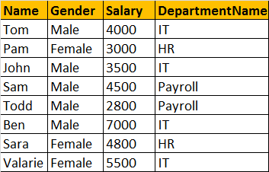
SELECT Name, Gender, Salary, DepartmentName
FROM tblEmployee
INNER JOIN tblDepartment
ON tblEmployee.DepartmentId = tblDepartment.Id
OR
SELECT Name, Gender, Salary, DepartmentName
FROM tblEmployee
JOIN tblDepartment
ON tblEmployee.DepartmentId = tblDepartment.Id
Note: JOIN or INNER JOIN means the same. It's always better to use INNER JOIN, as this explicitly specifies your intention.
If you look at the output, we got only 8 rows, but in the Employees table, we have 10 rows. We didn't get JAMES and RUSSELL records. This is because the DEPARTMENTID, in Employees table is NULL for these two employees and doesn't match with ID column in Departments table.
So, in summary, INNER JOIN, returns only the matching rows between both the tables. Non matching rows are eliminated.
LEFT JOIN or LEFT OUTER JOIN
Now, let's say, I want all the rows from the Employees table, including JAMES and RUSSELL records. I want the output, as shown below.
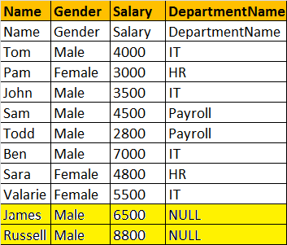
SELECT Name, Gender, Salary, DepartmentName
FROM tblEmployee
LEFT OUTER JOIN tblDepartment
ON tblEmployee.DepartmentId = tblDepartment.Id
OR
SELECT Name, Gender, Salary, DepartmentName
FROM tblEmployee
LEFT JOIN tblDepartment
ON tblEmployee.DepartmentId = tblDepartment.Id
Note: You can use, LEFT JOIN or LEFT OUTER JOIN. OUTER keyowrd is optional
LEFT JOIN, returns all the matching rows + non matching rows from the left table. In reality, INNER JOIN and LEFT JOIN are extensively used.
RIGHT JOIN or RIGHT OUTER JOIN
I want, all the rows from the right table. The query output should be, as shown below.
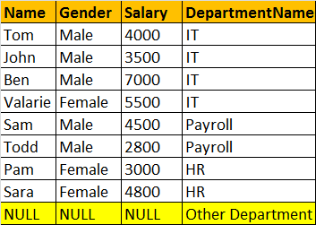
SELECT Name, Gender, Salary, DepartmentName
FROM tblEmployee
RIGHT OUTER JOIN tblDepartment
ON tblEmployee.DepartmentId = tblDepartment.Id
OR
SELECT Name, Gender, Salary, DepartmentName
FROM tblEmployee
RIGHT JOIN tblDepartment
ON tblEmployee.DepartmentId = tblDepartment.Id
Note: You can use, RIGHT JOIN or RIGHT OUTER JOIN. OUTER keyowrd is optional
RIGHT JOIN, returns all the matching rows + non matching rows from the right table.
FULL JOIN or FULL OUTER JOIN
I want all the rows from both the tables involved in the join. The query output should be, as shown below.
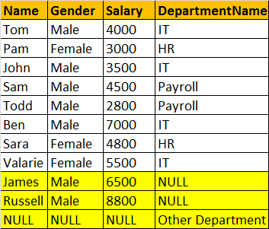
SELECT Name, Gender, Salary, DepartmentName
FROM tblEmployee
FULL OUTER JOIN tblDepartment
ON tblEmployee.DepartmentId = tblDepartment.Id
OR
SELECT Name, Gender, Salary, DepartmentName
FROM tblEmployee
FULL JOIN tblDepartment
ON tblEmployee.DepartmentId = tblDepartment.Id
Note: You can use, FULLJOIN or FULL OUTER JOIN. OUTER keyowrd is optional
FULL JOIN, returns all rows from both the left and right tables, including the non matching rows.
Joins Summary
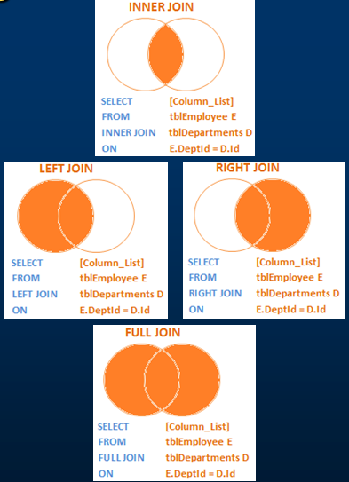
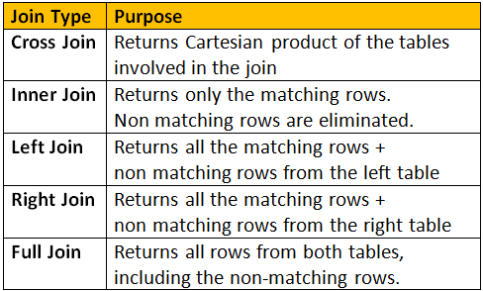

Left Join A

Considers Employees (tblEmployee) and Departments (tblDepartment) tables
Employee Table (tblEmployee)

Departments Table (tblDepartment)

How to retrieve only the non matching rows from the left table. The output should be as shown below:
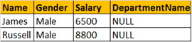
Query:
SELECT Name, Gender, Salary, DepartmentName
FROM tblEmployee E
LEFT JOIN tblDepartment D
ON E.DepartmentId = D.Id
WHERE D.Id IS NULL
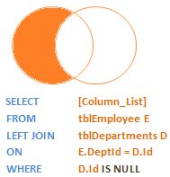
How to retrieve only the non matching rows from the right table
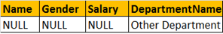
Query:
SELECT Name, Gender, Salary, DepartmentName
FROM tblEmployee E
RIGHT JOIN tblDepartment D
ON E.DepartmentId = D.Id
WHERE E.DepartmentId IS NULL
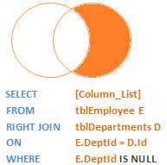
How to retrieve only the non matching rows from both the left and right table. Matching rows should be eliminated.
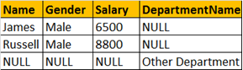
Query:
SELECT Name, Gender, Salary, DepartmentName
FROM tblEmployee E
FULL JOIN tblDepartment D
ON E.DepartmentId = D.Id
WHERE E.DepartmentId IS NULL
OR D.Id IS NULL
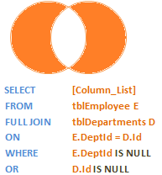

Self Join
A self join is used to join a table to itself. This can be useful for querying hierarchical data or comparing rows within the same table. Let’s consider an example with a table named Employees that has the following columns: EmployeeID, Name, and ManagerID.
drop table Employees
CREATE TABLE Employees (
EmployeeID INT PRIMARY KEY,
Name NVARCHAR(50),
ManagerID INT
);

INSERT INTO Employees (EmployeeID, Name, ManagerID) VALUES
(1, 'John Doe', NULL),
(2, 'Jane Smith', 1),
(3, 'Jim Brown', 1),
(4, 'Jake White', 2),
(5, 'Jill Green', 2);

SELECT
e1.Name AS Employee,
e2.Name AS Manager
FROM
Employees e1
LEFT JOIN
Employees e2 ON e1.ManagerID = e2.EmployeeID;
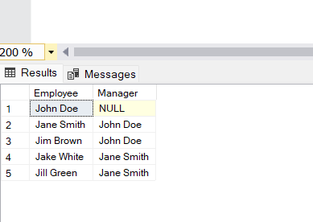

Group by Example
